# Final Year Project Report





**Session 2017**

**Scan Face:**

**Face Detection and Recognition**

**Project Supervisor**

**Dr. Sadiq Ali Khan**

**Submitted By**

|  |  |
| --- | --- |
| Muhammad Umer | EP-1449081 |
| Khalid Bin Huda Siddiqui | EP-1449041 |

Department of Computer Science

University of Karachi

Karachi

BS

Apr 27, 2018

A report submitted to the

Department of Computer Science

in partial fulfillment of the requirements for the

Degree

Bachelor of Science

in

Computer Science

by

Muhammad Umer

Khalid Bin Huda Siddiqui

University of Karachi

April 27, 2018

**Acknowledgements**

We truly acknowledge our deepest gratitude, cooperation and help make by Dr. Sadiq Ali Khan, Chairman Department of Computer Science, University of Karachi. He has been a constant source of guidance, constant attention, valuable suggestion, enthusiastic support and personal concern throughout the course of this project and give us the liberty to do our own work in any manner in any programming language that we want to do. We are also thankful to our friends and special appreciation goes to our loving parents who brought us here, and are always on our side, riding along with us on our ups and downs as well as giving us the encouragement to pursue our dreams. We say a big thank you for silent support led us to complete our project.

(Signed)

Muhammad Umer EP-1449081

Khalid Bin Huda Siddiqui EP-1449041

Date:

April 27, 2018

**Abstract**

This report includes a development presentation of Face Recognition and Face Detection with Event Management system for managing the people and student within a company or organization. The system as such, as it has been developed is called Event Management with Face Recognition System. It consists of functionally related GUI (application program) and database. The choice of the programming tools is individual and particular. It is a web-based system will be developed for admin/moderator to view the people attendance and allowing only those people who are registered and stop those people who are not registered. The main purpose to develop this project is to replace the current traditional system by provide faster, accurate, and efficient system. With this new face recognition system, it can eliminate some problems such as long queues, Voluntaries and manual work. In developing this project, evolutionary prototyping had been applied as methodology that controllers the direction of whole project development. This project is planned to develop using Spring Sts, MySQL and other related tools. Lastly, the implementation of this system will definitely provide more efficient, reliable, and the easiest and the accurate way to manage the all people. This project examines the issues related to any conference and event management and implements a web-based application for a fictitious consulting firm that participates in the placement of contractors in different organizations. The system is implemented using a 3-tier approach, with a backend database (MySQL database), a middle tier of Java Spring Boot, and a front-end web browser (client). This report also discusses each of the underlying technologies used to create and implement the application.

Table of Contents

Title………………………………….……………………………………………………..…………….I

Report Status Declaration Form……..……………………………………………....……...II

Declaration of Originality………………………………………………………………..……..II

Acknowledgement…………………………………………………………………………..….. III

Abstract…………………………………………………………………………………………..…..IV

Table of Contents………………………………………………..……………………………..…VI

**Chapter 1: Introduction** 7

1.1 Objective 7

1.1.1 Motivation 7

1.1.2 Introduction 7

1.2 Motivation and Problem Statement 7

1.2.1 Motivation 7

1.2.2 Problem Statement 8

1.2.2.A Manual Form Submission 8

1.2.2.B Letting them know that they are successfully registered or ‘Confirmation-Emai 8

1.2.2.C Need A lot Of volunteers 8

1.2.2.D Waste of time in checking people identity Cards at Gate. 8

1.2.2.E Marking Their attendance for Certificate 8

1.3 Project Objectives 8

1.4 Project Scope 9

1.5 Module Scope 9

1.5.1.A Admin Module 9

1.5.2.B People Module 10

1.5.3.C Face-Recognition Module 10

**Chapter 2 : Proposed Method/Approach** 11

2.1 Design Specifications 11

2.2 Initial Concept . 11

2.2.3 Design and implement initial concept 12

**Chapter 3: ALGORITHM: Histogram of oriented gradients** 13

3.1 Introduction 13

3.2 Theory 14

3.3 Feature Descriptor 15

3.4 Visualizing Histogram of Oriented Gradients 15

3.5 Encoding Faces 16

3.6 Comparison Between SIFT and HOG 17

3.7 Advantages 17

3.8 Disadvantage 17

**Chapter 4: Analysis and Desing** 18

4.1 System Design/Overview 18

4.2 TECHNOLOGIES 18

4.3 JAVA 18

4.4 Python 19

4.5 Web Server 19

4.6 IDE 19

4.7.SVN 19

4.8 Management 19

4.9.Frontend 19

4.9.1. Spring Framework 20

4.9.2 Spring MVC 20

4.9.3.JPA 21

4.9.4. Theamyleaf 21

4.9.5. Maven 22

4.9.6.I Webserver 23

4.9.7 Web Services 77

4.15 Entity-Relationship Diagram 26

4.17 Navigation Diagram 29

4..18 System and Architecture Diagram 31

4.19 Flow Diagram………………………………………………………………………………..32

**Chapter 5: Conclusion** 33

References 33

Appendix A: Glossary Of Terms 34

## Chapter 1: Introduction

**Objective:**

The target of this project is to develop system by the help of face detection and recognition, a system which capture images and process them using different software. Project include taking image from mobile phone and processing with python deep learning libraries with pre- processing and matching algorithm for face of a person and testing on different people and giving response whether the person is registered or not.

**Motivation:**

Management and Security are important part of this technology era. To solve problem of authentication many techniques are proposed but face detection and recognition is one of the most useful technique. A person face patterns are completely unique. The pattern of a person does not change quickly. The whole process of face recognition has different procedures i.e. finding face, encoding of the face, matching the face pattern with others.

**Introduction:**

### 1.2 Motivation and Problem Statement:

#### 1.2.1 Motivation:

The motivation to develop this project is to solve some problems that are currently occurring in every colleges/universities. This project purpose is to improve the current paper-based traditional event management system that is still in use by many colleges and universities. From the observation, most of the problems found are normally caused by the use of traditional system in these colleges and universities. Therefore, a face-recognition-based management system will be developed in order to solve these problems. The system is believed will be needed in order to improve the ways the colleges/universities in managing their attendees. Since most of the colleges/universities still using the traditional system, so, a bold assumption is made which most of the problems faced by these colleges/universities or other events are almost same. In addition, this project will be able to reduce the workload of every organizer and manage records since this system will record all incoming attendees accurately and allow only registered person only and automatically in every even. Besides that, people are giving their time to the organizer in order to gain knowledge that helps them in building up their future career. Therefore, every organization must provide the responsibilities in ensuring that only those people are allow those are registered.

#### 1.2.2 Problem Statement

While Organizing an event or any kind of conference we need do some step and these step a lot of time and effort as well as man power.

1. **Manual Form Submission.**

Throughout the step, the organizer and the volunteers are manually submitting the form and manually doing this take time and can be error-prone process.

1. **Letting them know that they are successfully registered or ‘Confirmation-Email’.**

Most of the time, while submitting the form manually we face many problem, one of main problem is telling the person that you are successfully registered or not due to some reason such as no space left or other.

1. **Need A lot Of volunteers.**

Doing in the traditional way you need a lot of volunteers and man power and finding the right volunteer can be a problem.

1. ***Waste of time in checking people identity Cards at Gate*.**

It take a lot of time to manually check each person that they are registered or not. And checking identity of every person can be hand.

1. ***Marking Their attendance for Certificate***

Giving certificate to the attendees can be a problem because you have to check they are present in the event or not.

### 1.3 Project Objectives:

In developing this system, some project objectives had been specified. The main purpose of this project is to improve the current existing employee attendance system that in use by most of the organization and colleges/universities by develop a face recognition system system. Some objectives of this project had been identified and listed below.

1. To replace the current existing system process to fully computerized and automated event management system.
2. To develop a Web-based application for the System.
3. To develop a web-based form, through which we can get the information about the member.
4. To get the Http video Stream from the Android mobile camera.
5. To check whether the person is registered or not.
6. To provide easier method in to mark the attendance and time at which he comes.

### 1.4 Project Scope:

The project scope of this project is to develop a Web-Based face recognition System. In this project, Web-based based form are used to obtain the data of attendees. There are some modules covered in the product scope.

Train Model Module

**1.5 Module: Scope**

Module Scope

Admin module

People module

Face Recognition module

Email module

Attendance module

Figure 1.5-F1: Modules covered in the Project Scope.

## a. Admin Module

In the admin module, it allows the admin to register as a new admin or login with email address and a password. The can privilege authority to go through all the features of the system. The admin can start the process of face recognition and can do appropriate stuff.

## b. People Module

In the People module, it allows the user to enter the information to registered for the event.. The use has to enter email address, name , National identity card and a recent picture of him

## c. Face-Recognition Module

In the face recognition module, it is used to get video stream from the Http and give it to the python face recognition library to calculate different features of the face and check whether the person is registered or not and with the help of opencv we check and predict whose face is this and at the same time save in our database.

If person and face of the person is registered it will show “the name of that person” otherwise it shows “unknown”.

## d. Train Model Module

In the Train the model module, we give all the label picture of the people to the python and it train the model and the train model has 90 percent accuracy

## e. Email Module

In the email module, it is used to send the email to the user as a notification to let the people know that they are successfully registered with help of google Mail.

**f. Attendance Module**

In the attendance module, it is used to mark the attendance of the person who are in the event

## Chapter 2 : Proposed Method/Approach

### Design Specifications:

Firstly, the methodology chosen in carry out this project is Evolutionary Prototyping which is one of the prototyping methodologies. Evolutionary prototyping can be referred to as a form of software development method in which an initial prototype is developed and refined through a number of cycles and lastly to the final complete system (Sommerville, 2000). The reason to implement the evolutionary prototyping methodology in this project is because it allows the developer continuously getting feedbacks and suggestions for system improvements of the prototype that had been presented to the user until the final system is delivered. Evolutionary prototyping had consist of four phases which includes initial concept, design and implement initial prototype, refine prototype, and deliver complete system.

There is some strength that can be found from the evolutionary prototyping methodology. Evolutionary prototyping can help developers to speed up their system development. In addition, evolutionary prototyping help in improve the quality of final product since it needs to undergo few prototypes and lastly to the final version after the overall functionalities and requirements met. Besides that, chances to increase the satisfaction of end-users in using the system will be high since every generated prototype is based on the requirement specified by the end-users.

However, there are some weaknesses that can be found from the evolutionary prototyping methodology. First of all, it is hard to predict the completion date and the cost of the project since requirement can be change from time to time based on the end-users requirement. In addition, if there is any uncertainty, it can cause the developer to feel frustrated due to the money, time, and effort sacrificed previously. Besides that, the behind code of the software may occur high chances to be damaged or poorly structured due to the frequent changes make to meet the requirement specified by the end-users from time-to-time.

### Methodologies and General Work Procedures:

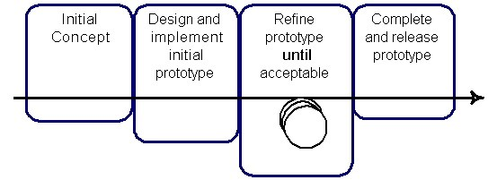

Figure 3.2-F1: *Evolutionary Prototyping Model*

## a. Initial Concept

During the first phase, there is a need to identify the all basic requirements in developing the system. The developer will come out with the creation of initial concept and identify the required materials that related to the project in this phase. Thus, the developer may need to gather the requirements by conducting survey to those who seem likely will involve in the system development such as lecturer, employee, and etc. From the result obtained from the survey, the developer will identify the business plan as an initial input from the user in developing this system. Through the business plan, the developer will be able to specify and create the project plan regarding to the project. In addition, the established project plan will provide information to the developer which includes the schedule of the project, clear description of the project, and etc. At the end of this phase, the developer will need to come out with business plan, project plan, and a list of initial requirements from the users as an output for this phase. Therefore, the initial concept to replace the current existing employee attendance system process to fully-computerized and automated employee attendance system had been stated. So, one of the objectives had been stated in this phase.

## b. Design and implement initial concept :

In the previous phase, the developer had identified all the basic information which includes the business plan, project plan, and a list of initial requirements from the users. So, in this phase, the developer will perform the design activities and implement the initial concept in developing the system. First of all, the development of prototyping of the basic user interface will be established for a purpose to show to the users as to make sure that the development is moving toward the right direction. The established basic user interfaces will includes the interface of fingerprint employee attendance system in order to provide the clear images to the users what the system will look like. At the same time, the developer will perform the initial system design analysis based on the listed requirements in this phase. After developing the interface and identified the initial system design, the user interface is created and show to the users for a purpose to let the users evaluate the prototypes of the interface of the system. Next, the developer will then record the feedback from the users after the evaluation and modify the requirements according to the information provided by the users in this phase. After all, the basic user interfaces developed in this phase are archived and will not be use anymore. At the end of this phase, the developer will need to come out with a list of validated requirements, system design, and evaluation and feedback from the users about the missing requirements and etc.

**Chapter 3: ALGORITHM: Histogram of oriented gradients**

**Introduction:**

The histogram of oriented gradients (HOG) is a feature descriptor used in computer vision and image processing for the purpose of object detection. The technique counts occurrences of gradient orientation in localized portions of an image. This method is similar to that of edge orientation histograms, scale-invariant feature transform descriptors, and shape contexts, but differs in that it is computed on a dense grid of uniformly spaced cells and uses overlapping local contrast normalization for improved accuracy. Robert K. McConnell of Wayland Research Inc. first described the concepts behind HOG without using the term HOG in a patent application in 1986. In 1994 the concepts were used by Mitsubishi Electric Research Laboratories. However, usage only became widespread in 2005 when Navneet Dalal and Bill Triggs, researchers for the French National Institute for Research in Computer Science and Automation (INRIA), presented their supplementary work on HOG descriptors at the Conference on Computer Vision and Pattern Recognition (CVPR). In this work they focused on pedestrian detection in static images, although since then they expanded their tests to include human detection in videos, as well as to a variety of common animals and vehicles in static imagery.

**Theory:**

The essential thought behind the histogram of oriented gradients descriptor is that local object appearance and shape within an image can be described by the distribution of intensity gradients or edge directions. The image is divided into small connected regions called cells, and for the pixels within each cell, a histogram of gradient directions is compiled. The descriptor is the concatenation of these histograms. For improved accuracy, the local histograms can be contrast-normalized by calculating a measure of the intensity across a larger region of the image, called a block, and then using this value to normalize all cells within the block. This normalization results in better invariance to changes in illumination and shadowing. The HOG descriptor has a few key advantages over other descriptors. Since it operates on local cells, it is invariant to geometric and photometric transformations, except for object orientation. Such changes would only appear in larger spatial regions. Moreover, as Dalal and Triggs discovered, coarse spatial sampling, fine orientation sampling, and strong local photometric normalization permits the individual body movement of pedestrians to be ignored so long as they maintain a roughly upright position. The HOG descriptor is thus particularly suited for human detection in images.

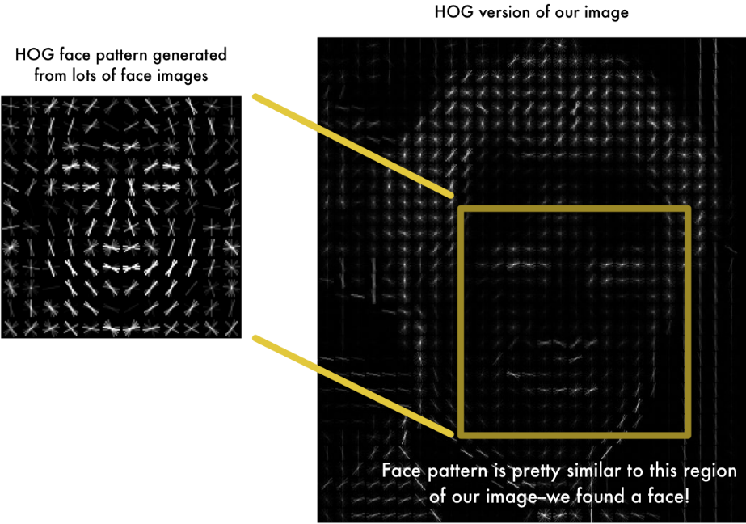

In the above picture you can see that how HOG face pattern looks and how gradient works.

**Feature Descriptor:**

A feature descriptor is a representation of an image or an image patch that simplifies the image by extracting useful information and throwing away extraneous information. Typically, a feature descriptor converts an image of size width x height x 3 (channels ) to a feature vector / array of length n. In the case of the HOG feature descriptor, the input image is of size 64 x 128 x 3 and the output feature vector is of length 3780. Keep in mind that HOG descriptor can be calculated for other sizes, but in this post I am sticking to numbers presented in the original paper so you can easily understand the concept with one concrete example. This all sounds good, but what is “useful” and what is “extraneous” ? To define “useful”, we need to know what is it “useful” for ? Clearly, the feature vector is not useful for the purpose of viewing the image. But, it is very useful for tasks like image recognition and object detection. The feature vector produced by these algorithms when fed into an image classification algorithms like Support Vector Machine (SVM) produce good results. But, what kinds of “features” are useful for classification tasks ? Let’s discuss this point using an example. Suppose we want to build an object detector that detects buttons of shirts and coats. A button is circular ( may look elliptical in an image ) and usually has a few holes for sewing. You can run an edge detector on the image of a button, and easily tell if it is a button by simply looking at the edge image alone. In this case, edge information is “useful” and color information is not. In addition, the features also need to have discriminative power. For example, good features extracted from an image should be able to tell the difference between buttons and other circular objects like coins and car tires. In the HOG feature descriptor, the distribution ( histograms ) of directions of gradients ( oriented gradients ) are used as features. Gradients ( x and y derivatives ) of an image are useful because the magnitude of gradients is large around edges and corners ( regions of abrupt intensity changes ) and we know that edges and corners pack in a lot more information about object shape than flat regions.

**Visualizing Histogram of Oriented Gradients:**

The HOG shows that dominant direction of the histogram captures the shape of the person, especially around the torso and legs. Unfortunately, there is no easy way to visualize the HOG descriptor in OpenCV.

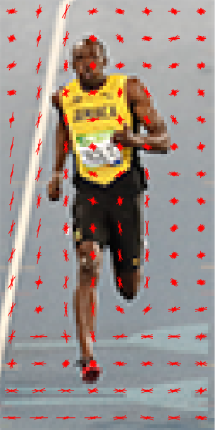

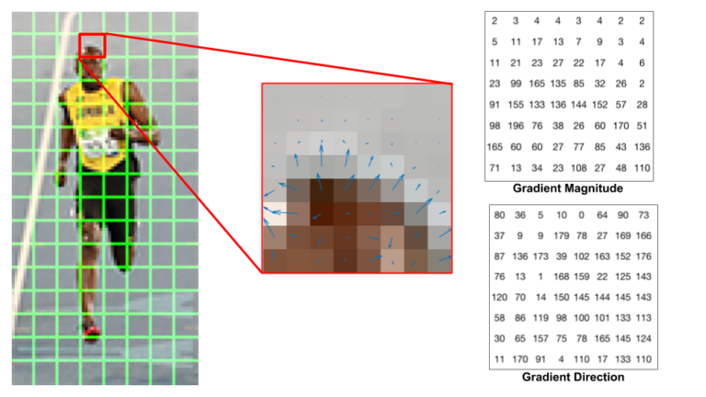

**Center** : The RGB patch and gradients represented using arrows.

**Right** : The gradients in the same patch represented as numbers

The image in the center is very informative. It shows the patch of the image overlaid with arrows showing the gradient  the arrow shows the direction of gradient and its length shows the magnitude. Notice how the direction of arrows points to the direction of change in intensity and the magnitude shows how big the difference is. On the right, we see the raw numbers representing the gradients in the 8×8 cells with one minor difference, the angles are between 0 and 180 degrees instead of 0 to 360 degrees

#### Encoding Faces:

The measurements should we collect from each face to build our known face database may be it is Ear size or Nose length or Eye color or Something else.

The Researchers have discovered that the most accurate approach is to let the computer figure out the measurements to collect itself. Deep learning does a better job than humans at figuring out which parts of a face are important to measure. The solution is to train a Deep Convolutional Neural Network. But instead of training the network to recognize pictures objects like we did, we are going to train it to generate 128 measurements for each face. The training process works by looking at 3 face images at a time: Load a training face image of a known person Load another picture of the same known person Load a picture of a totally different person Then the algorithm looks at the measurements it is currently generating for each of those three images. It then tweaks the neural network slightly so that it makes sure the measurements it generates for #1 and #2 are slightly closer while making sure the measurements for #2 and #3 are slightly further apart: After repeating this step millions of times for millions of images of thousands of different people, the neural network learns to reliably generate 128 measurements for each person. Any ten different pictures of the same person should give roughly the same measurements.

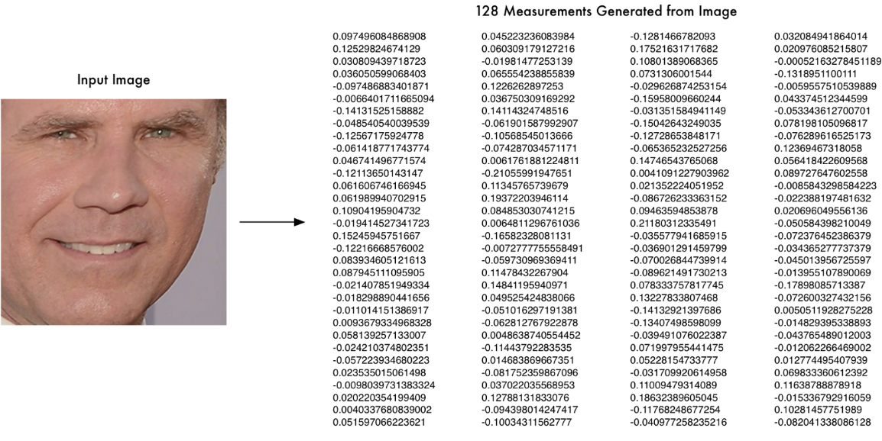

**Comparison Between SIFT and HOG:**

SIFT (Scale-Invariant Feature Transform) over HOG in case when we have to extract features from a sequence of frames of an activity.

1. In SIFT gaussian smoothing is applied in order to compute the DOG (difference of gaussian). Then performing Scale Extrema Detection you will detect the feature points. Once you have this feature points you will need to compute the HOG for each feature. Since it takes a 16x16 neighbourhood the result will be a 128 length descriptor. Whereas HOG compute edge gradient of a whole image and find orientation of each pixel so it can generate a histogram.
2. HOG is used to extract global feature whereas SIFT is used for extracting      local features.
3. SIFT is also scale and rotation invariant whereas HOG is not scale and rotation invariant.
4. HOG is a dense feature extraction method for images. Dense means that it extracts features for all locations in the image (or a region of interest in the image) as opposed to only the local neighborhood of keypoints like SIFT

**Advantages:**

1. HOG use in For satellite imagery.
2. HOG descriptors may be used for object recognition by providing them as features to a [machine learning](https://en.wikipedia.org/wiki/Machine_learning) algorithm. Object like car, tree and building.
3. HOG descriptors capture such outline information, and are simpler, less powerful, and faster (~20x) alternatives to neural networks
4. HOG descriptors as features in a [support vector machine](https://en.wikipedia.org/wiki/Support_vector_machine) (SVM)

**Disadvantage:**

HOG-based classifiers lack the power of neural network classifiers, and so may break down in crowded or complex scenes. There are a number of advantages to HOG-based classifiers, however. HOG features can be extracted via the CPUs of a laptop or computing cluster, so GPUs are not necessary. HOG-based classifiers are also extremely fast to train and evaluate, which enables confidence level estimation via training multiple classifiers combined with bootstrap resampling.

## Chapter 4 : System Analysis and Design

### System Design/Overview:

In describing how the project is designed, diagrams will be sketch in this session to make clear on how the project will be written, how it function, how it install, and etc. In previously, I have studied the Object-Oriented System Analysis and Design (OOSAD). Therefore, this session will includes all the diagrams that I had learnt from the OOSAD subject. The diagrams included are use-case diagram, activity-flow diagram, entity-relationship diagram, sequence diagram, object diagram, and etc. With the help of the diagrams, it will be able to assists the readers to understand more easily regarding the new system. Other than diagrams, the database design will also be perform in this session for a purpose to specify all the required entities in this system. These also include the CRC cards, use-case description, and etc. In addition, drawing prototype of whole system interface will be included in this session to give a clear image to the reader/user how the system will look like and how it will function. The purpose of the drawing prototype is to obtain initial feedback from the reader/user before the first real prototype begins development.

**TECHNOLOGIES:**

## 1.1 JAVA

* Spring Boot(1.4.2)
* Spring Security
* Spring MVC
* JPA
* Thymeleaf
* Maven (3.3.9)
* Eclipse (Neon, 4.6.0)
* Java 8
* Packaging (JAR)

**1.2 PYTHON**

* Face Recognition Libraries
* Dlib
* Numpv
* OpenCV

## WEB SERVER

* Tomcat

## IDE

* Spring STS
* MYSQL Workbench

## SVN

* GIT
* GitHub

## Management

* Jira
  1. **FRONTEND**

Bulma framework

**Descriptions:**

## SPRING FRAMEWORK:

* **SPRING BOOT**

Spring Boot makes it easy to create stand-alone, production-grade Spring based Applications that you can "just run". We take an opinionated view of the Spring platform and third-party libraries so you can get started with minimum fuss. Most Spring Boot applications need very little Spring configuration.

## Features

* Create stand-alone Spring applications
* Embed Tomcat, Jetty or Undertow directly (no need to deploy WAR files)
* Provide opinionated 'starter' POMs to simplify your Maven configuration
* Automatically configure Spring whenever possible
* Provide production-ready features such as metrics, health checks and externalized configuration
* Absolutely no code generation and **no requirement for XML** configuration.
* **SPRING MVC**

The Spring Web MVC framework provides Model-View-Controller (MVC) architecture and ready components that can be used to develop flexible and loosely coupled web applications. The MVC pattern results in separating the different aspects of the application (input logic, business logic, and UI logic), while providing a loose coupling between these elements.

* The **Model** encapsulates the application data and in general they will consist of POJO.
* The **View** is responsible for rendering the model data and in general it generates HTML output that the client's browser can interpret.
* The **Controller** is responsible for processing user requests and building an appropriate model and passes it to the view for rendering.
* **Spring Security:**

Spring Security is one of the Spring Framework’s Security modules. It is a Java SE/Java EE Security Framework to provide Authentication, Authorization, SSO and other Security features for Web Applications or Enterprise Applications.

Spring Security Framework provides the following Features:

1. Authentication and Authorization.
2. Supports BASIC,Digest and Form-Based Authentication.
3. Supports LDAP Authentication.
4. Supports OpenID Authentication.
5. Supports SSO (Single Sign-On) Implementation.
6. Supports Cross-Site Request Forgery (CSRF) Implementation.
7. Supports “Remember-Me” Feature through HTTP Cookies.
8. Supports Implementation of ACLs
9. Supports “Channel Security” that means automatically switching between HTTP and HTTPS.
10. Supports I18N (Internationalisation).
11. Supports JAAS (Java Authentication and Authorization Service).
12. Supports Flow Authorization using Spring WebFlow Framework.
13. Supports WS-Security using Spring Web Services.
14. Supports Both XML Configuration and Annotations. Very Less or minimal XML Configuration.

* **JPA:**

Spring Data JPA API provides JpaTemplate class to integrate spring application with JPA.

JPA (Java Persistent API) is the sun specification for persisting objects in the enterprise application. It is currently used as the replacement for complex entity beans.

The implementation of JPA specification are provided by many vendors such as:

* Hibernate
* OpenJPA
* **THEAMYLEAF:**

Thymeleaf is a Java library. It is an XML/XHTML/HTML5 template engine able to apply a set of transformations to template files in order to display data and/or text produced by your applications.

It is better suited for serving XHTML/HTML5 in web applications, but it can process any XML file, be it in web or in standalone applications.

The main goal of Thymeleaf is to provide an elegant and well-formed way of creating templates. In order to achieve this, it is based on XML tags and attributes that define the execution of predefined logic on the DOM (Document Object Model), instead of explicitly writing that logic as code inside the template.

Its architecture allows a fast processing of templates, relying on intelligent caching of parsed files in order to use the least possible amount of I/O operations during execution.

And last but not least, Thymeleaf has been designed from the beginning with XML and Web standards in mind, allowing you to create fully validating templates if that is a need for you.

* **MAVEN:**

Maven’s primary goal is to allow a developer to comprehend the complete state of a development effort in the shortest period of time. In order to attain this goal there are several areas of concern that Maven attempts to deal with:

* Making the build process easy
* Providing a uniform build system
* Providing quality project information
* Providing guidelines for best practices development
* Allowing transparent migration to new features
* **PYTHON LIB:**

We use python`s face recognition library. It recognize and manipulate faces by using [dlib](http://dlib.net/)’s state-of-the-art face recognition. It is based on deep learning. The model we are using has the accuracy of 99.38% on the [Labeled Faces in the Wild](http://vis-www.cs.umass.edu/lfw/) benchmark.

* **DLIB:**

Dlib is a general purpose [cross-platform](https://en.wikipedia.org/wiki/Cross-platform) software [library](https://en.wikipedia.org/wiki/Library_(computing)) written in the programming language [C++](https://en.wikipedia.org/wiki/C%2B%2B). Its design is heavily influenced by ideas from [design by contract](https://en.wikipedia.org/wiki/Design_by_contract) and [component-based software engineering](https://en.wikipedia.org/wiki/Component-based_software_engineering). Thus it is, first and foremost, a set of independent software components. It is [open-source software](https://en.wikipedia.org/wiki/Open-source_software) released under a [Boost Software License](https://en.wikipedia.org/wiki/Boost_(C%2B%2B_libraries)#License).

* **OPENCV:**

OpenCV (Open Source Computer Vision) is a [library of programming functions](https://en.wikipedia.org/wiki/Library_(computing)) mainly aimed at real-time [computer vision](https://en.wikipedia.org/wiki/Computer_vision). Originally developed by [Intel](https://en.wikipedia.org/wiki/Intel_Corporation), it was later supported by [Willow Garage](https://en.wikipedia.org/wiki/Willow_Garage) and is now maintained by Itseez. The library is [cross-platform](https://en.wikipedia.org/wiki/Cross-platform) and free for use under the [open-source](https://en.wikipedia.org/wiki/Open-source) [BSD license](https://en.wikipedia.org/wiki/BSD_license). OpenCV supports the [deep learning](https://en.wikipedia.org/wiki/Deep_learning) frameworks [TensorFlow](https://en.wikipedia.org/wiki/TensorFlow" \o "TensorFlow), [Torch](https://en.wikipedia.org/wiki/Torch_(machine_learning))/[PyTorch](https://en.wikipedia.org/wiki/PyTorch" \o "PyTorch) and [Caffe](https://en.wikipedia.org/wiki/Caffe_(software)" \o "Caffe (software)).

OpenCV has a modular structure, which means that the package includes several shared or static libraries

The following modules are available:

* [**Core functionality**](https://docs.opencv.org/3.2.0/d0/de1/group__core.html) - a compact module defining basic data structures, including the dense multi-dimensional array Mat and basic functions used by all other modules.
* [**Image processing**](https://docs.opencv.org/3.2.0/d7/dbd/group__imgproc.html) - an image processing module that includes linear and non-linear image filtering, geometrical image transformations (resize, affine and perspective warping, generic table-based remapping), color space conversion, histograms, and so on.
* **video** - a video analysis module that includes motion estimation, background subtraction, and object tracking algorithms.
* **NUMPY:**

NumPy, which stands for Numerical Python, is a library consisting of multidimensional array objects and a collection of routines for processing those arrays. Using NumPy, mathematical and logical operations on arrays can be performed. This tutorial explains the basics of NumPy such as its architecture and environment. It also discusses the various array functions, types of indexing.

## Webserver

* **TOMCAT:**

Apache Tomcat, often referred to as Tomcat Server, is an open-source [Java Servlet Container](https://en.wikipedia.org/wiki/Servlet_container) developed by the [Apache Software Foundation](https://en.wikipedia.org/wiki/Apache_Software_Foundation) (ASF). Tomcat implements several [Java EE](https://en.wikipedia.org/wiki/Java_Platform,_Enterprise_Edition) specifications including [Java Servlet](https://en.wikipedia.org/wiki/Java_Servlet), [JavaServer Pages](https://en.wikipedia.org/wiki/JavaServer_Pages" \o "JavaServer Pages) (JSP), [Java EL](https://en.wikipedia.org/wiki/Unified_Expression_Language), and [WebSocket](https://en.wikipedia.org/wiki/WebSocket" \o "WebSocket), and provides a "pure [Java](https://en.wikipedia.org/wiki/Java_(programming_language))" [HTTP](https://en.wikipedia.org/wiki/Hypertext_Transfer_Protocol) [web server](https://en.wikipedia.org/wiki/Web_server) environment in which [Java](https://en.wikipedia.org/wiki/Java_(programming_language)) code can run.

Tomcat is developed and maintained by an open community of developers under the auspices of the Apache Software Foundation, released under the [Apache License](https://en.wikipedia.org/wiki/Apache_License) 2.0 license, and is [open-source software](https://en.wikipedia.org/wiki/Open-source_software).

## IDE

* **Spring STS**

The Spring Tool Suite is an Eclipse-based development environment that is customized for developing Spring applications. It provides a ready-to-use environment to implement, debug, run, and deploy your Spring applications, including integrations for Pivotal tc Server, Pivotal Cloud Foundry, Git, Maven, AspectJ, and comes on top of the latest Eclipse releases.

Included with the Spring Tool Suite is the developer edition of Pivotal tc Server, the drop-in replacement for Apache Tomcat that's optimized for Spring. With its Spring Insight console, tc Server Developer Edition provides a graphical real-time view of application performance metrics that lets developers identify and diagnose problems from their desktops.

## SVN

* **GIT**

Git is a [version control system](https://en.wikipedia.org/wiki/Version_control_system) for tracking changes in [computer files](https://en.wikipedia.org/wiki/Computer_file) and coordinating work on those files among multiple people. It is primarily used for [source code management](https://en.wikipedia.org/wiki/Source_code_management) in [software development](https://en.wikipedia.org/wiki/Software_development), but it can be used to keep track of changes in any set of files. As a [distributed revision control](https://en.wikipedia.org/wiki/Distributed_revision_control) system it is aimed at speed, data integrity and support for distributed, non-linear workflows.

* Bulma framework:

Bulma is an open source CSS framework based on Flexbox and built with Sass. It's 100% responsive, fully modular, and available for free.

**WEB Services:**

# 1.Registration(admin)

The application calls registration Controller. It check whether the Email address is already registered or not. And also validate all other field then Server will generate a unique id and save it to the database.

## Registering new Admin

#### URL:

Request method is Post.

<http://localhost:8080/registration>

## Registering new person

You have to input valid detail such as name, Nic, email address and a picture whose size is less than 5 megabytes.

#### URL

Request method is Post.

<http://localhost:8080/welcome>

Response:

If the registration is successful you will get Email about it.

## Training the Model

For tanning the model you have to have to request to Controller and then controller create a child process to communicate with python model of deep learning.

#### URL

Request method is GET.

[http://localhost:8080 /admin/pyexe](http://localhost:8080%20/admin/pyexe%20)

Response:

If the registration is successful you will get a message of “Successfully trained”.

## Checking the People(Registered or Not)

1. For checking and starting a opencv to check and verify the person, you have to have to request to checking Controller and then controller create a child process to communicate with python and start the process.

#### URL

Request method is GET.

[http://localhost:8080/ admin/pyexetrain](http://localhost:8080/welcome)

Response:

If will give whether the person is registered or not.

### 4.15 Entity-Relationship Diagram

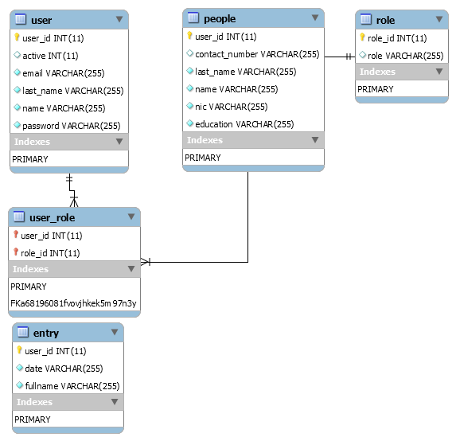

Figure 4.15-F1: Entity-Relationship Diagram

### 4.16 Data Dictionary

**User role Entity**

|  |  |  |  |  |
| --- | --- | --- | --- | --- |
| Field | Type | Null | Key | Default |
| user_id | int(11) | NO | PRI | NULL |
| role_id | int(11) | NO | PRI | NULL |

Table 4.16-F1: Table of user_role

**User Entity**

|  |  |  |  |  |  |  |
| --- | --- | --- | --- | --- | --- | --- |
| Field | Type | Null | Key | Default | Extra |  |
| user_id | int(11) | NO | PRI | NULL | auto_increment | |
| Active | int(11) | YES |  | NULL |  |  |
| Email | varchar(255) | NO |  | NULL |  |  |
| last_name | varchar(255) | NO |  | NULL |  |  |
| Name | varchar(255) | NO |  | NULL |  |  |
| password | varchar(255) | NO |  | NULL |  |  |

Table 4.16-F2: Table of User

**Role Entity**

|  |  |  |  |  |  |  |
| --- | --- | --- | --- | --- | --- | --- |
| Field | Type | Null | Key | Default | Extra |  |
| role_id | int(11) | NO | PRI | NULL | auto_increment | |
| Role | varchar(255) | YES |  | NULL |  |  |
|  |  |  |  |  |  |  |

Table 4.16-F3: Table of Role Entity

**People Entity**

|  |  |  |  |  |  |  |
| --- | --- | --- | --- | --- | --- | --- |
| Field | Type | Null | Key | Default | Extra |  |
| user_id | int(11) | NO | PRI | NULL | auto_increment | |
| contact_number | varchar(25) | YES |  | NULL |  |  |
| last_name | varchar(25) | NO |  | NULL |  |  |
| Name | varchar(25) | NO |  | NULL |  |  |
| Nic | varchar(25) | NO |  | NULL |  |  |
| Education | varchar(25) | NO |  | NULL |  |  |

Table 4.16-F4: Table of People Entity

**Entry Entity**

|  |  |  |  |  |  |  |
| --- | --- | --- | --- | --- | --- | --- |
| Field | Type | Null | Key | Default | Extra |  |
| user_id | int(11) | NO | PRI | NULL | auto_increment | |
| date | varchar(255) | NO |  | NULL |  |  |
| fullname | varchar(255) | NO |  | NULL |  |  |

Table 4.16-F5: Table of Entry Entity

### 4.17 Navigation Diagram

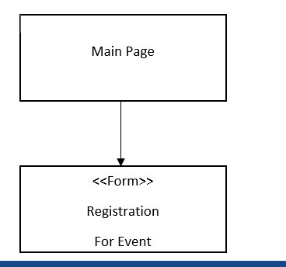Figure 4.17-F1: Navigation Diagram (admin)

Figure 4.17-F2: Navigation Diagram (user)

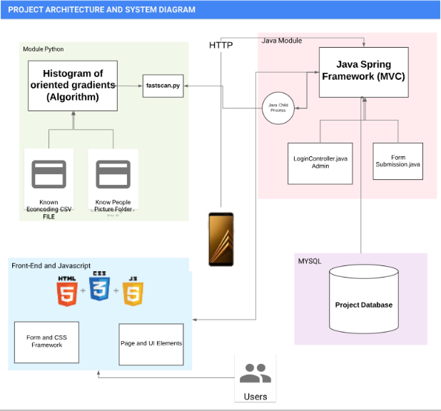**System and Architecture Diagram:**

The above picture show how all the module of the project works and how frontend works and how the spring boot controller control all the app and communicate with python module. The process start from User.

**Flow Diagram:**

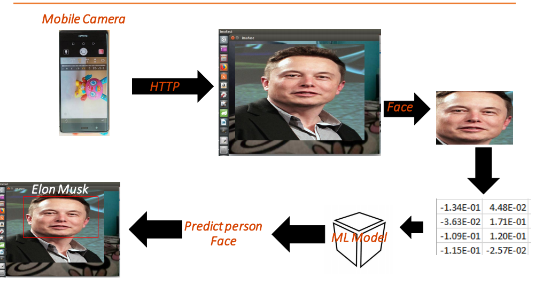

The above picture shows that the picture with the help of http protocol move to the system where first system detect the picture then with the help of machine learning model convert into encoding and then predict he person.

**Screenshot:**

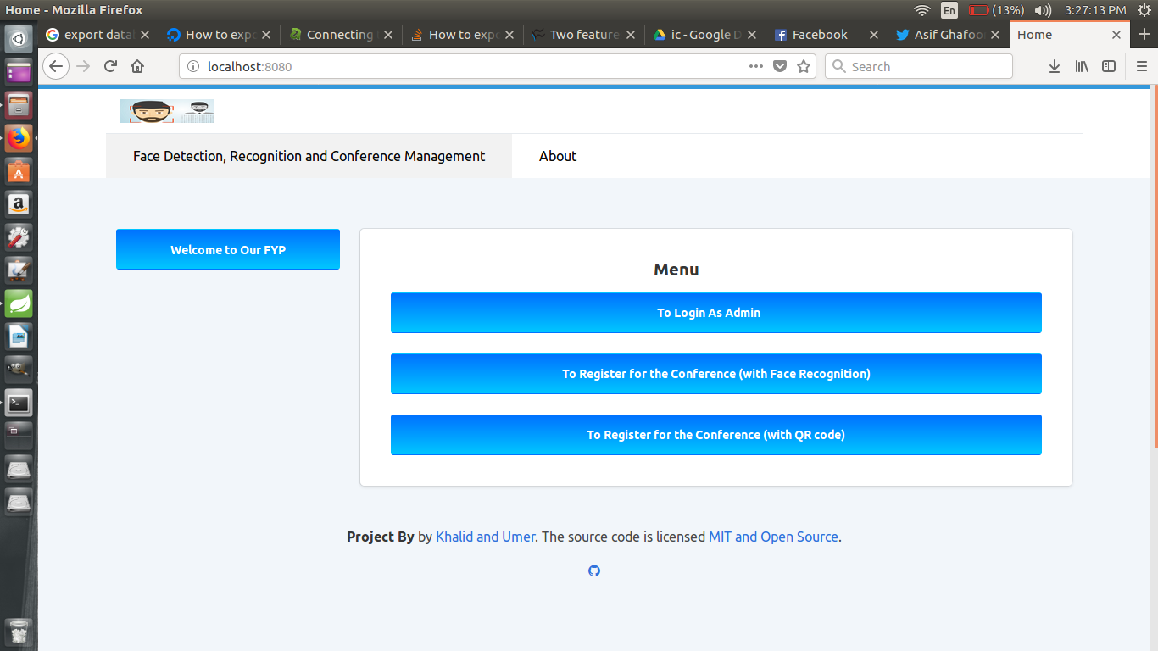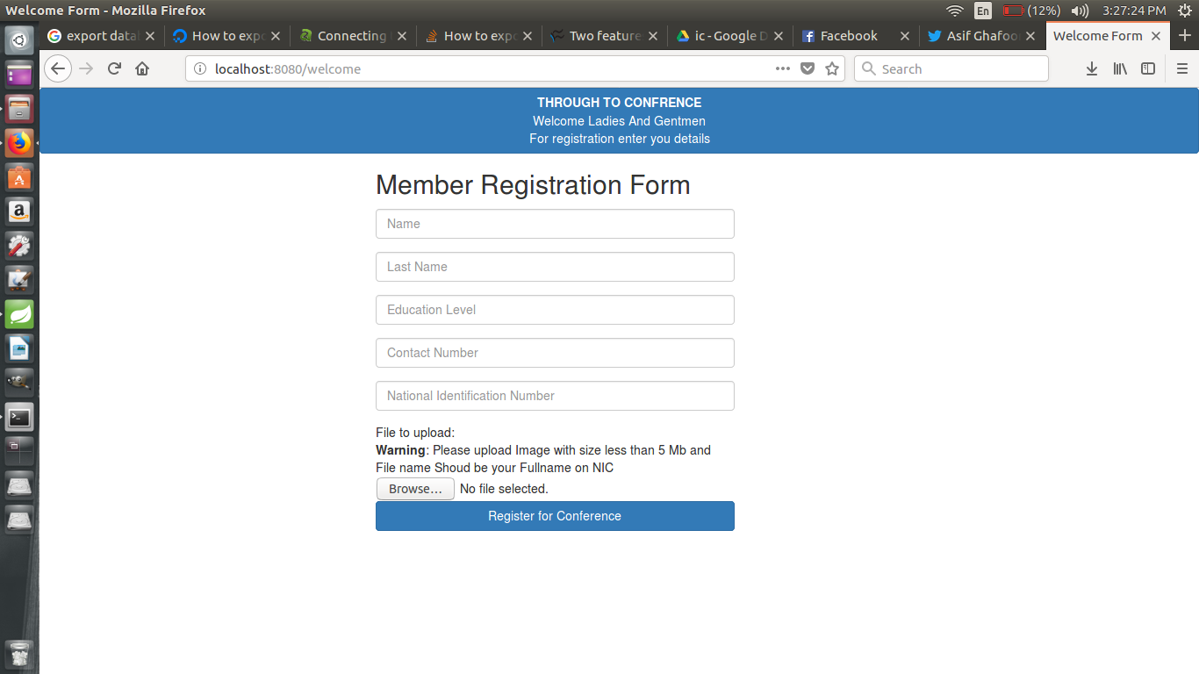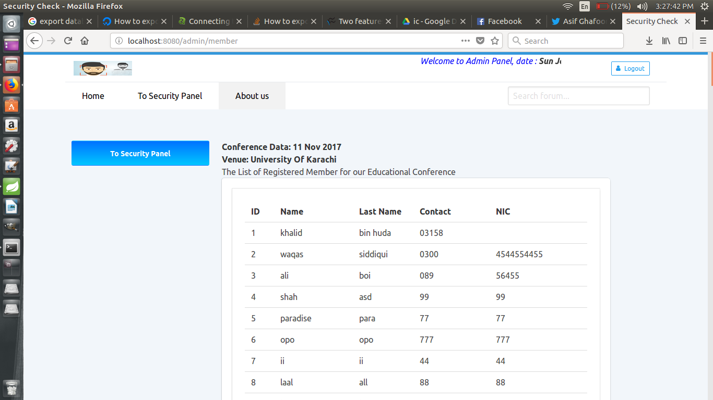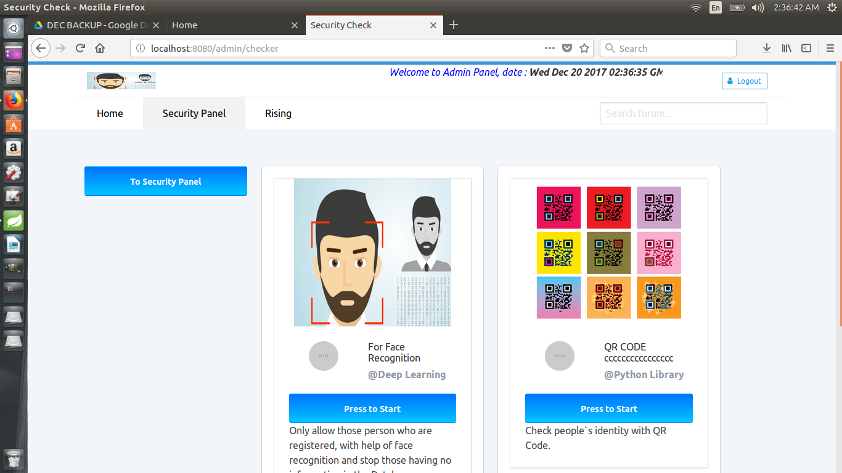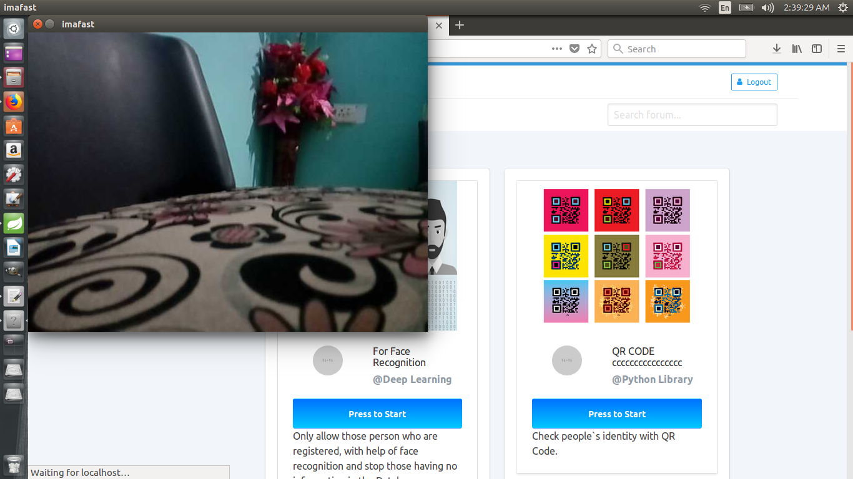



## Chapter 5 : Conclusion

In conclusion, Face recognition system will be developed to replace the traditional management system that are currently widely using by many colleges, universities and other Event Manager. This system is designed to make the whole attendance as well as allowing registered people and taking process to become more reliable, convenient, efficient, and accurate. Besides that, with the implementation of this technology will help in reduce errors and attendance data will be able to compile in easier way.

This project is designed to aim in eliminating spotted problems during the initial analysis. The problems spotted are includes buddy-signing, manual work, voluntaries, loss of attendance sheet, skip office issue, and hard in checking weather person is registered or not. These problems are the major problems faced by most colleges and universities while arranging any event. If view from the Pareto analysis side which also known as 80-20 rule, 80 percent of the problems are always caused by the 20 percent problems. In short, it means that most of the problems faced are mostly because of the usage of traditional employee attendance system.

Therefore, this project is designed in effort to eliminate these problems. Some solution had been applied to eliminate these problems which includes the use of face Recognition technology, change the current system to fully-computerized system, provide easier way to check weather a person is registered or not.. With the proposed solutions, obviously seen not only can eliminate these spotted problems but at the same time also promote a very reliable ways in managing the employee attendance record.

## References:

1. [Adam Geitgey](https://medium.com/@ageitgey?source=post_header_lockup)

# Machine Learning is Fun! Part 4: Modern Face Recognition with Deep Learning

* + *.* Available at:

[<](http://www.researchgate.net/publication/245025631_Bar_Code_Scanner_Based_Student_Attendance_System_(SAS))https://medium.com/@ageitgey/machine-learning-is-fun-part-4-modern-face-recognition-with-deep-learning-c3cffc121d78 [>](http://www.researchgate.net/publication/245025631_Bar_Code_Scanner_Based_Student_Attendance_System_(SAS)) [Accessed 11 July 2017].

* + Robin David opencv

Available at: [<](http://ethesis.nitrkl.ac.in/2214/1/thesis.pdf) http://www.robindavid.fr/opencv-tutorial/ [>](http://ethesis.nitrkl.ac.in/2214/1/thesis.pdf) [Accessed 17 July 2017].

* <https://en.wikipedia.org/wiki/Feature_extraction>
* <http://library.wolfram.com/infocenter/Demos/395/>

**Appendix A:**

**Glossary Of Terms**

**E**

ER: Entity Relationship Diagram

**H**

HOG : histogram of oriented gradients

**M**

MVC: Model View Controller

ML : Machine learning

**S**

SIFT: scale-invariant feature transform

Spring STS: Spring Tool Suite